# Solent University

# Coursework Assessment Brief

# Assessment Details

|  |  |
| --- | --- |
| Unit Title: | Data Science |
| Unit Code: | COM603 |
| Unit Leader: | Cedric Mesnage |
| Level: | 6 |
| Assessment Title: | Data Science |
| Assessment Number: | 1 |
| Assessment Type: | Software Product with Report |
| Restrictions on Time/Word Count: | 2500 words |
| Consequence of not meeting time/word count limit: | It is essential that assignments keep within the time/word count limit stated above. Any work beyond the maximum time/word length permitted will be disregarded and not accounted for in the final grade. |
| Individual/Group: | Individual |
| Assessment Weighting: | 100% |
| Issue Date: | 23rd September 2019 |
| Hand In Date: | 17th January 2020 |
| Planned Feedback Date: | 14th February 2020 (4 working weeks after hand-in) |
| Mode of Submission: | On-line (via ‘Solent Online Learning’) |
| Number of copies to be submitted: | 1 |
| Anonymous Marking | This assessment will be marked anonymously |

# Assessment Task

# Global warming is a problem that has been clearly identified as a result of human industrialisation which led to disastrous gas emissions in the atmosphere. The climate is getting warmer each year due to the lack of ozone in the stratosphere and the presence of greenhouse gases.

# You have been tasked to present a proposal on how we can tackle the issue of global warming. You should complete and document the following steps:

**Task 1**

Research the topic of global warming and outline ideas on how Data Science can help. List potential solutions and how to influence policy makers.

**Task 2**

Based on your knowledge of Next Generation Databases discuss the advantages of the different NoSQL database categories to store climate change data.

**Task 3**

Find a relevant dataset to climate change (for instance global sea level or average global temperature, effect of planting trees/deforestation, gas emissions of cars, planes, ships, veganism...) on https://toolbox.google.com/datasetsearch and write a Python script to load the data and import it in a MongoDB database.

**Task 4**

Write 3 JavaScript queries to access your data from your MongoDB database.

**Task 5**

Based on your knowledge of Data Science and your readings, discuss the different data mining methods that can be applied to climate change data and what insights they can give you.

**Task 6**

Use https://toolbox.google.com/datasetsearch to find a relevant dataset, open it with Orange and plot the data with a Scatterplot.

**Task 7**

Recall how the Kmeans algorithm functions and the purpose of clustering. Apply the Kmeans algorithm to cluster data. You might need to process the data or link it with another dataset. For instance you could cluster UK cities based on their gas emissions levels.

**Task 8**

Apply a classification tree and a classification tree viewer to the output of kmeans. Produce the screenshot of the tree and interpret the results.

**Task 9**

Explain the APRIORI algorithm to compute frequent item sets. What is the complexity of the problem of finding frequent item sets and what is the technique used to improve its efficiency. If applicable find association rules on your data or find another relevant dataset for instance you could find patterns of pollution levels and economic activities in regions.

**Task 10**

Use linear regression and polynomial regression to predict the global average temperature in the coming 30 years compare and discuss the results.

# Assessment criteria

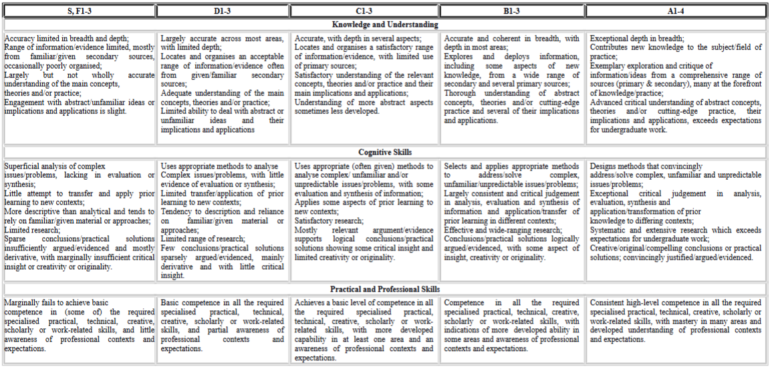

# Learning Outcomes

This assessment will enable students to demonstrate in full or in part the learning outcomes identified in the unit descriptors.

# Late Submissions

Students are reminded that:

1. If this assessment is submitted late i.e. within 5 working days of the submission deadline, the mark will be capped at 40% if a pass mark is achieved;
2. If this assessment is submitted later than 5 working days after the submission deadline, the work will be regarded as a non-submission and will be awarded a zero;
3. If this assessment is being submitted as a referred piece of work then it must be submitted by the deadline date; any Refer assessment submitted late will be regarded as a non-submission and will be awarded a zero.

<http://portal.solent.ac.uk/documents/academic-services/academic-handbook/section-2/2o-assessment-principles-and-regulations.pdf?t=1534423842941>

# Extenuating Circumstances

The University’s Extenuating Circumstances procedure is in place if there are genuine circumstances that may prevent a student submitting an assessment. If students are not 'fit to study’, they can either request an extension to the submission deadline of 5 working days or they can request to submit the assessment at the next opportunity (Defer). In both instances students must submit an EC application with relevant evidence. If accepted by the EC Panel there will be no academic penalty for late submission or non-submission dependent on what is requested. Students are reminded that EC covers only short term issues (20 working days) and that if they experience longer term matters that impact on learning then they must contact the Student Hub for advice.

A summary of guidance notes for students is given below:

<http://portal.solent.ac.uk/documents/academic-services/academic-handbook/section-2/2p-extenuating-circumstances.pdf?t=1534423896787>

# Academic Misconduct

Any submission must be students’ own work and, where facts or ideas have been used from other sources, these sources must be appropriately referenced. The University’s Academic Handbook includes the definitions of all practices that will be deemed to constitute academic misconduct. Students should check this link before submitting their work.

Procedures relating to student academic misconduct are given below:

<http://portal.solent.ac.uk/support/official-documents/information-for-students/complaints-conduct/student-academic-misconduct.aspx>

**Ethics Policy**

The work being carried out by students must be in compliance with the Ethics Policy. Where there is an ethical issue, as specified within the Ethics Policy, then students will need an ethics release or an ethical approval prior to the start of the project.

The Ethics Policy is contained within Section 2S of the Academic Handbook:

<http://portal.solent.ac.uk/documents/academic-services/academic-handbook/section-2/2s-university-ethics-policy.pdf>

**Grade marking**

The University uses a letter grade scale for the marking of assessments. Unless students have been specifically informed otherwise their marked assignment will be awarded a letter grade. More detailed information on grade marking and the grade scale can be found on the portal and in the Student Handbook.

<http://portal.solent.ac.uk/documents/academic-services/academic-handbook/section-2/2o-annex-2-assessment-regulations-grade-marking-scale.pdf?t=1534424273208>

**Guidance for online submission through Solent Online Learning (SOL)**

<http://learn.solent.ac.uk/onlinesubmission>